Indefinite Integral
Hossein Rahimzadeh
www.cafeplanck.com
info@cafeplanck.com

Type 1
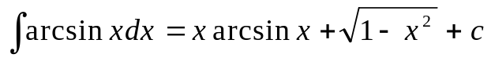
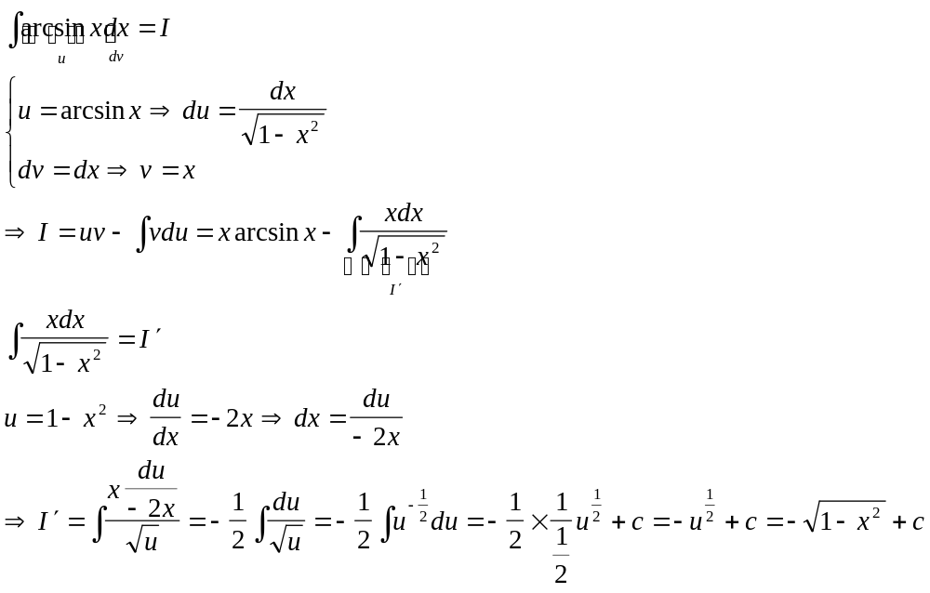

Type 2
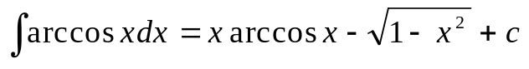
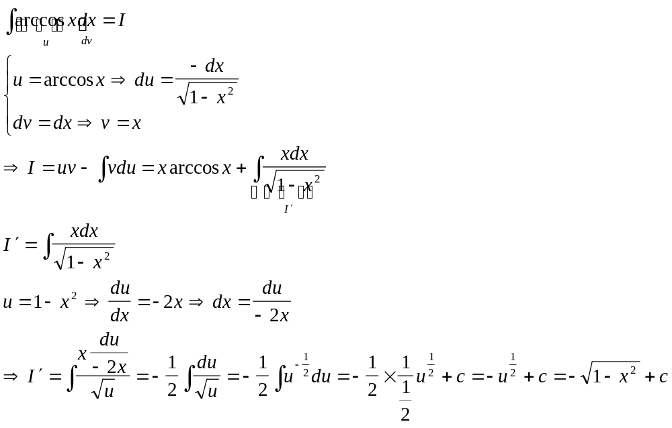

Type 3

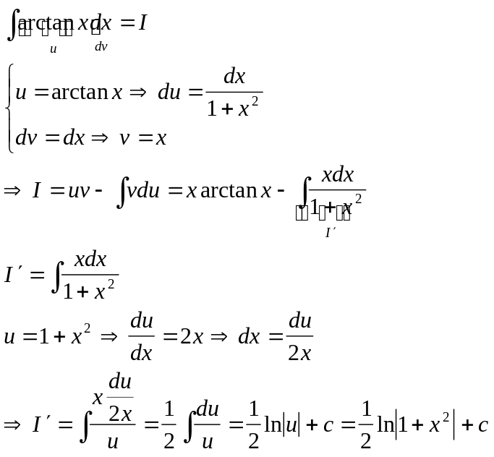

Type 4

